**NAGIOS**

**Server:**

wget <http://assets.nagios.com/downloads/nagiosxi/xi-latest.tar.gz>

tar xzf xi-latest.tar.gz

cd nagiosxi

./fullinstall

http://<IP address>/nagiosxi

**client node CENTOS:**

install NRPE Package on this machine

<https://kb.op5.com/display/HOWTOs/Installation+of+NRPE+agent+on+CentOS+and+RHEL#sthash.Z9aPVWHp.dpbs>

<https://tecadmin.net/install-nrpe-on-centos-rhel/>

apt-get update -y

**Step 1 – Install EPEL Repository**

### On CentOS/RHEL - 7 ###

rpm -Uvh http://dl.fedoraproject.org/pub/epel/7/x86_64/Packages/e/epel-release-7-11.noarch.rpm

### On CentOS/RHEL - 6 ###

rpm -Uvh http://dl.fedoraproject.org/pub/epel/6/x86_64/epel-release-6-8.noarch.rpm

## Step 2 – Install NRPE and Nrpe-plugins

yum --enablerepo=epel -y install nrpe nagios-plugins

## Step 3 – Configure NRPE

vim /etc/nagios/nrpe.cfg

allowed_hosts=127.0.0.1, **192.168.1.110**

**add server ip address**

## Step 4 – Start NRPE Service

sudo systemctl enable nrpe.service

sudo systemctl start nrpe.service

**client node UBUNTU:**

install NRPE Package on this machine

<https://tecadmin.net/install-nrpe-on-ubuntu/>

<https://support.nagios.com/kb/article.php?id=8>

sudo apt-get update -y

sudo apt-get install nagios-nrpe-server nagios-plugins -y

vi **/etc/nagios/nrpe.cfg**

allowed_hosts=127.0.0.1, 192.168.1.100

**add server ip address**

sudo /etc/init.d/nagios-nrpe-server restart

**client node WINDOWS:**

install NS CLIENT++ Package on this machine

<http://nsclient.org/download/>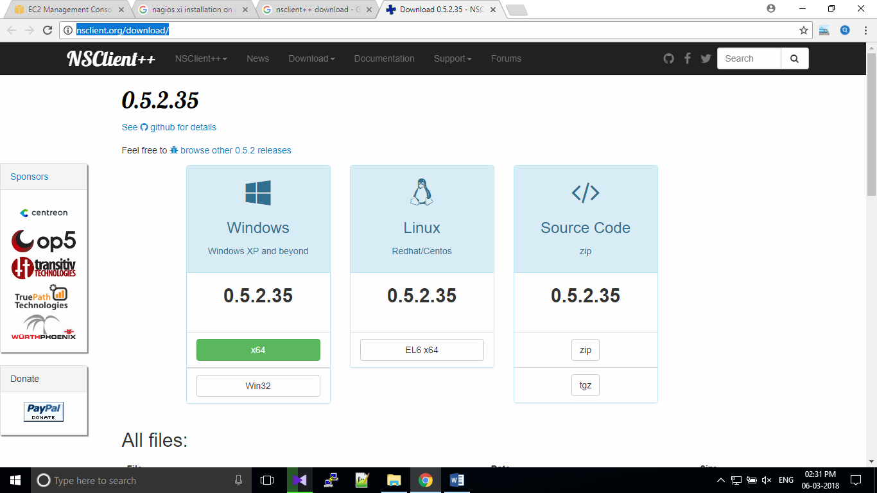

open this file

C:\Program Files\nsclinet++\nsclient (Configuration file)

allowed_hosts=127.0.0.1, **192.168.1.110**

**add server ip address**

**other commands**

yum install nrpe Nagios-plugins*

install all plugins

service nrpe restart

delete client before delete all services in this client then delete client

nsclient restart service

ls /usr/lib64/Nagios/plugins/

show the available plugins details

/usr/local/nagios/etc/objects

Nagios HOME folder

/usr/local/Nagios/bin/Nagios -v /usr/local/nagios/etc/